COVID-19 MESSAGE FROM ISC S K REGION
January 18, 2021

Hello/Tansi,

As the resurgence of COVID-19 activity continues across Saskatchewan, it is important for everyone to continue with
Individual precautions to protect ourselves, our families and our communities. While we continue to prepare the way for widespread control of COVID-19 through safe and effective vaccines, Saskatchewan needs a collective effort, from public health authorities and individuals, as a range of public health measures and restrictions are implemented to interrupt rapid spread of the virus. Go the extra mile by sharing credible information on COVID-19 risks and prevention practices and measures to reduce COVID-19 in communities. Thank you for continuing to do your part.

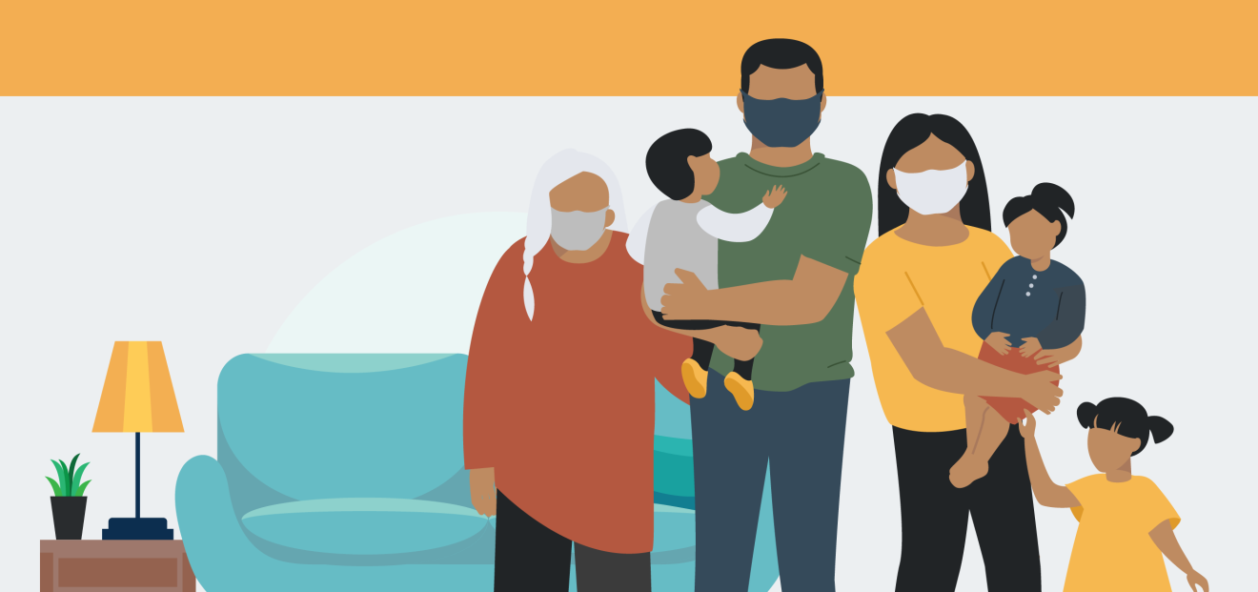

UPDATES

On January 15, the Prime Minister releases supplemental mandate letter for ministers.
On January 15, Major General Dany Fortin, vice-president of logistics and operations at the Public Health Agency of Canada and head of the country’s vaccine distribution efforts, joins federal ministers Patty Hajdu (health), Dominic LeBlanc (intergovernmental affairs), and Treasury Board president Jean-Yves Duclos to provide an update on the federal response to the ongoing COVID-19 pandemic. Major General Fortin says that Pfizer will be delivering an average of 50 percent fewer doses of its vaccine over the next four weeks. The quantity of doses delivered will increase towards the end of February. This temporary reduction is due to the company’s expansion plans aimed at increasing production capacity at its European manufacturing facility.
On January 14, the Saskatchewan Health Authority approved with a broadened application for First Nations communities where everyone over 40 should be immunized at the same time.
On January 14, the Prime Minister Justin Trudeau provided an update on the federal response to COVID-19.
On January 13th, Minister Marc Miller re-announced $1.2 billion in investments to support the ongoing public health response to COVID-19 in Indigenous communities. This funding includes $380 million Indigenous Community Support Fund, $631.6 million over two years for Indigenous Public Health measures and $186.8 million over two year for long–term care.

COVID-19 VACCINE UPDATE
Together the health system will immunize all Saskatchewan resident s who want to receive the vaccine. National guidelines and local epidemiology guides decision making regarding vaccine strategy, allocation, sequencing, and prioritization.Existing immunization knowledge will be leveraged at the provincial and local level.

Saskatchewan is currently in Phase 1 of its COVID-19 vaccine distribution; priority groups in this phase
include long-term care and personal care home residents and staff, residents 70 years of age and older, First Nations residents 40 years and older, residents 50 years and older living in northern and remote communities, and prioritizied health care workers. This phase is estimated to last until March 2021.
View the extended COVID-19 dashboard for additional data
CASES IN FIRST NATIONS COMMUNITIES

As of January 18, there are 3466 confirmed COVID-19 cases reported in Saskatchewan First Nation communities:
1151 active cases, 2293 recoveries and 22 Indigenous residents with COVID-19 have died.

VACCINE:WHAT YOU SHOULD KNOW
COVID-19 has radically changed daily life. The COVID-19 vaccine offers us the ability to develop immunity to the virus, but not without many questions being raised.
How can a vaccine have been developed so quickly?
How does the vaccine work?
How can I be assured that it’s safe?
What kind of reaction might I have to the vaccine?
What kind of follow-up will there be on the effect of the vaccine?
For more info please visit Saskatchewan.ca/COVID19.

Learn about First Nation leaders share vaccine experiences online to combat hesitation, misinformation
https://www.cbc.ca/amp/1.5876063?__twitter_impression=true

Wondering if vaccines are safe? Watch this video: https://www.canada.ca/en/public-health/services/video/vaccine-safety.html

Find out about Canada’s COVID19 Immunization Plan: https://www.canada.ca/content/dam/phac-aspc/documents/services/diseases/2019-novel-coronavirus-infection/canadas-reponse/canadas-covid-19-immunization-plan-en.pdf

Find out about the Government of Saskatchewan’s Vaccine Delivery Strategy: https://www.saskatchewan.ca/government/health-care-administration-and-provider-resources/treatment-procedures-and-guidelines/emerging-public-health-issues/2019-novel-coronavirus/covid-19-vaccine

REGIONAL CONTACTS

Please continue to send your questions and requests related to COVID-19 to aadnc.skemergency.aandc@canada.ca
Visit our Saskatchewan portal for links to a variety of
COVID-19 resources in various Indigenous languages.

